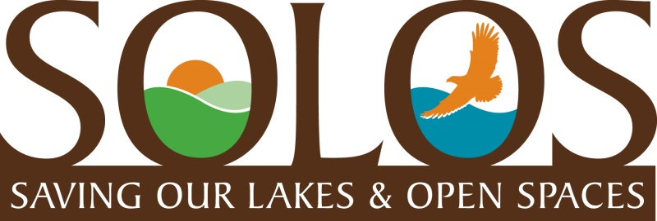
COMMUNITY UPDATE
MAY 2017
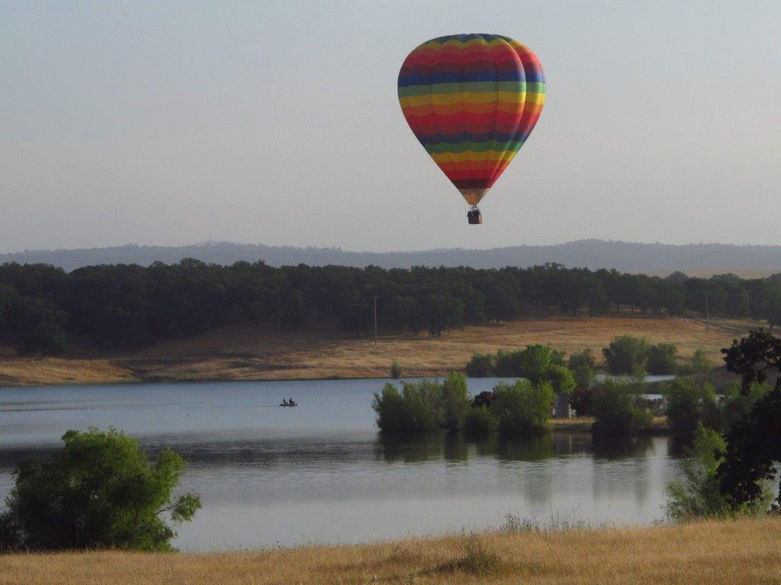
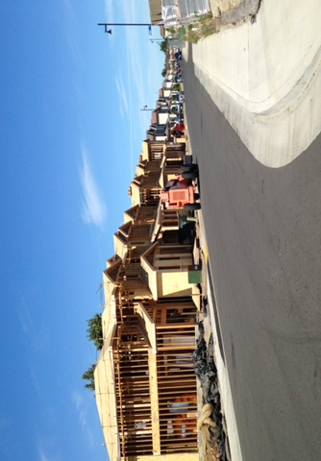
Summer has arrived! Temperatures are in the 90’s, lots of folks fishing on the back lakes, and the balloon excursions will be starting soon. We snapped this balloon photo on a Sunday morning last year. What a perfect breeze they had with a picnic brunch ready for their touchdown on the other side. SOLOS members continually ask me if this beautiful land on the far side of Lake Calero is part of the Rancho North proposed development plan, and will that beautiful heritage oak canopy, that you can see well in this photo, be affected? The answer is, yes. You are looking at “Village G” which proposes 50 lots on the far right side of Calero and on the far shore under the balloon in this photo. Balloon floating will be a rare activity in this area should the proposed development get approved.

April 2017 Rancho North Properties Submits New Maps and Updated Development Plan to Sacramento County Planning Department
Rancho North Properties was asked by the County to make some revisions in their previously submitted plans and maps for their proposed development of 795 homes in Villages A-H. Villages D-H are located around our back lakes with 316 homes proposed. Homes, and streets, and sidewalks, and traffic……..oh my! Not to mention the excess demand on our water, security, environmental habitat and local services. The next step in the development application process is for a new Notice of Preparation (NOP) to be issued by Sac County Planning. It will be similar to the last NOP which lists 13 environmental areas, such as traffic, water supply, endangered species, etc. each of which the developer must submit a plan on how each area will be considered, mitigated, and/or addressed as a condition of approval. The County Planning Dept. will then draft an Environmental Impact Report (EIR) which either confirms the developer’s plans or recommends/requires revisions. The process is extremely tedious and long with Public Hearings held to allow the public and public agencies to comment on areas of the NOP, and then again to comment on the draft EIR. The NOP Public Hearings might be held this fall, but the draft EIR Public Hearings won’t be until next year. To say this development proposal is highly complicated might be an understatement. The environmental impact will be huge and, it certainly appears that the expense and development process exorbitant and challenging.
(You can view the full map at this link…….
file:///C:/Users/Admin/Downloads/Planningdocument.pdf

SOLOS Membership tops 800!
We are happy to report that our SOLOS Membership is now over 800 residents. This not only confirms how much people care about Rancho Murieta and our beautiful wilderness environment, but it also confirms that people support our focus of working towards finding a way to “preserve” the land around our back lakes. SOLOS members will be called on in the future to re-submit their letters written for the last NOP, to be on record for the new NOP as well as, and also to write new letters. Members will also be called on to attend important meetings concerning our local agencies of RMA and CSD as they deal with many issues concerning the proposed development. And lastly, members will be asked to help us continue to build our membership to meet our goal of 1000 by September 2017. Please ask you neighbors and RM friends to send their contact info to solosrm@aol.com It is that easy!
Thank you for your support and interest.
Cheryl McElhany, President (solosrm@aol.com)

