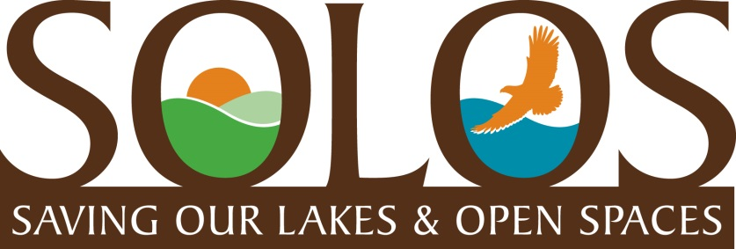
COMMUNITY UPDATE
FEBRUARY 2017
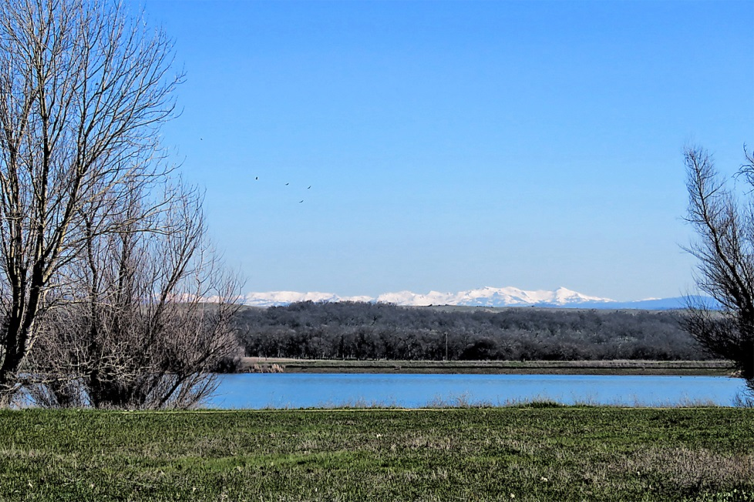
Wow! Full reservoirs, over-flowing creeks and rivers, and tons of snow in the mountains………. Is this still California??? And, a local grocery store finally opened, too. Life is pretty good in Rancho Murieta right now, environmentally speaking, at least. SOLOS is working with local developers and governing agencies towards growth solutions that will not endanger our open spaces and quality of life.
Lake Calero and the beautiful snow-covered Sierras
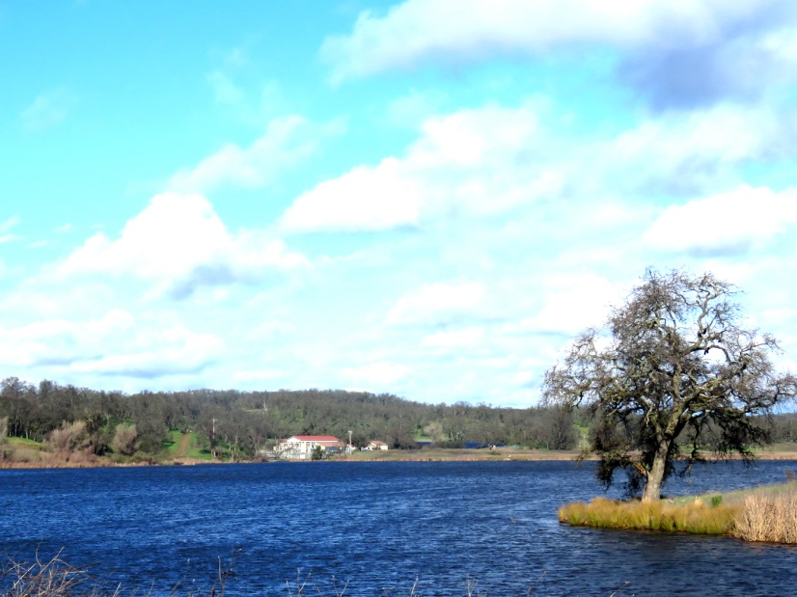
Lake Clementia Power House, Jan. 2017
Environmental Impact Report (EIR) Update
The Rancho North Properties application for new development in Rancho Murieta has been stalled at the Sacramento County Planning Dept. since last Spring while the County hosted a series of community meetings attended by various “stakeholder” groups in the community and the Developer. Organizations, such as RMA, CSD, the Country Club, SOLOS, RM Trail Stewards, and local ranchers attended the meetings to voice their concerns, from their prospective, to the Developers as part of this planning process. Recommendations in many areas were offered to the Developers. SOLOS, of course, offered the most restrictive recommendations, in that we are greatly concerned about the impact of proposed development that will cause traffic congestion, contamination of our reservoirs, reduction of our beautiful open spaces, and damage to our precious wildlife habitat. So, we proposed that Rancho North Properties enter into a joint agreement with our community governing agencies to create a “Preserve” of the land around Lakes Calero, Chesbro, and Clementia, rather than develop this property into housing tracts. Such an agreement might involve a combination of donated, purchased, and/or trade of land, services, and/or amenities. And, the creation of a “Preserve” would be a gift to our community forever.
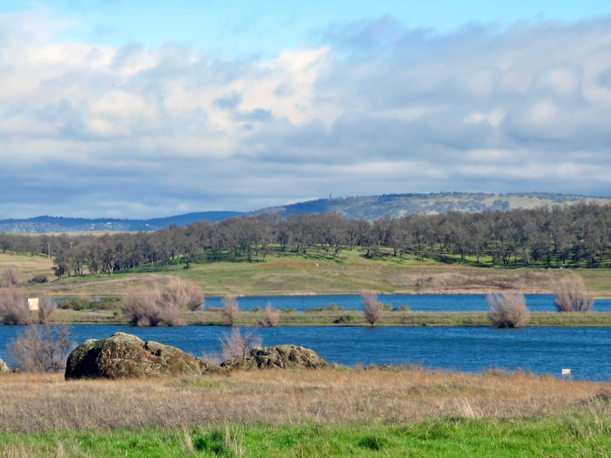
So many people tell us, and we see it every day in the realtor ads, that our beautiful, back lakes and our convenient and close wilderness environment are the reasons they moved to Rancho Murieta. These are truly spectacular features in our community and should be protected. Just think how much better it will be if this beautiful environmental wilderness is “preserved” forever. Such an enhancement to your property value is hard to match.
You can support the “Preserve” vision by writing letters and/or talking to your elected officials on CSD, RMA, and Sue Frost, our newly elected Sacramento County Board Supervisor. Help us share the vision!

Lake Calero is back to full capacity!
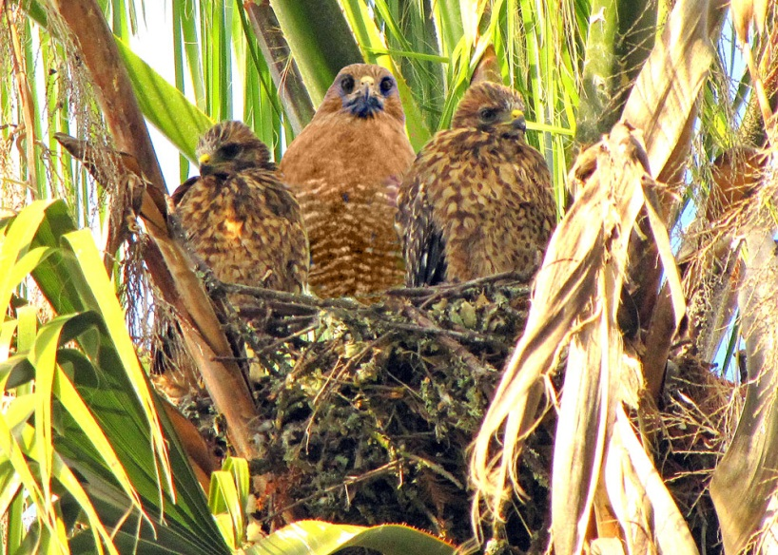
Hawk mother & babies in palm tree off of Da La Cruz Dr.

Swainson’s Hawk Habitat
We are not sure if these are Swainson Hawks, but we know Rancho Murieta has many of them in our beautiful wildlife habitat. Recently the Sacramento Valley Conservancy(SVC) approved a conveyance of conservation easement along with funding to ensure perpetual management for Swainson’s Hawk nests which has led to a significant increase in observed nests in surrounding regional habitats such as the Bufferlands. SOLOS is interested in having discussions with the SVC about extending conservation easements for Swainson’s Hawk to Rancho Murieta’s wildlife habitat, as well. Stay tuned for more information on this topic.
Join SOLOS and please encourage your RM neighbors and friends to join as well.
SOLOS is a nonprofit PAC dedicated to environmental preservation. For more information go to www.ranchomurieta.com/solos or email us at solosrm@aol.com. To join send your contact information to solosrm@aol.com.

