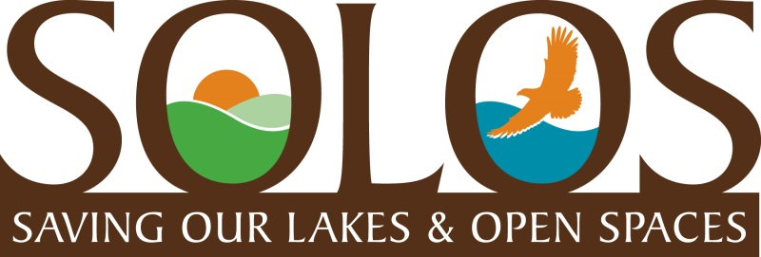
COMMUNITY UPDATE
June 2017
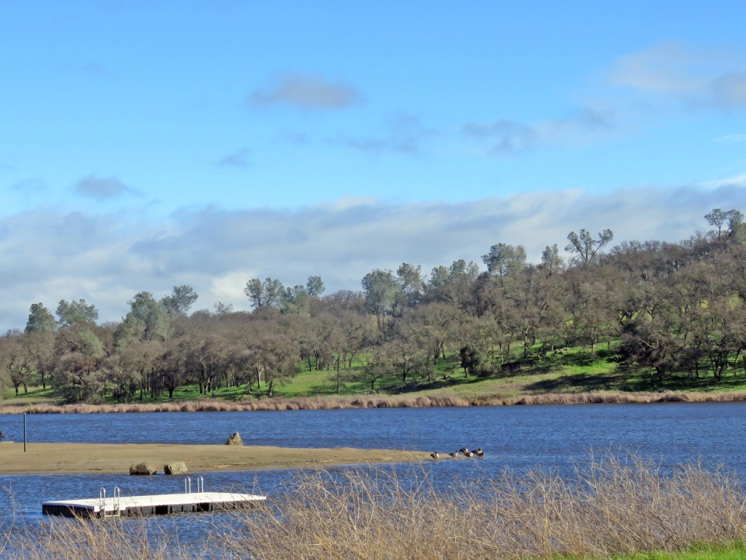
Summer has arrived! Temperatures are starting to sizzle and the swimming beach and platform are ready for swimmers and picnics at Lake Clementia.
SOLOS members have asked me if this beautiful land on the far side of Lake Clementia is part of the Rancho North proposed development plan, and will that beautiful heritage oak canopy, that you can see well in this photo, be affected? The answer is the same as I said last month regarding the land on the far side of Lake Calero……. yes. You are looking at “Village E” which proposes 32 residences on the far side of Lake Clementia, which will most certainly affect the heritage oak canopy, as well as interrupt the Bald Eagles nesting area and habitat, and spoil some beautiful hiking trails and the serenity of Lake Jean. We encourage you all to take the beautiful hike on the other side of Lake Clementia that goes past Lake Jean. The view is totally amazing and you will feel like you have found peace and tranquility just minutes away from your home.
Nothing New To Report Regarding Rancho North Development Proposal.
This past April, Rancho North Properties submitted new maps and an updated Development Plan to Sacramento County Planning Department which included some revisions to their previously submitted plans and maps for their proposed development of 795 homes in Villages A-H. Villages D-H are located around our back lakes with 316 homes proposed. The next step in the development application process is for a new Notice of Preparation (NOP) to be issued by Sac County Planning. It will be similar to the last NOP which lists 13 environmental areas, such as traffic, water supply, endangered species, etc. each of which the developer must submit a plan on how each area will be considered, mitigated, and/or addressed as a condition of approval. The County Planning Dept. will then draft an Environmental Impact Report (EIR) which either confirms the developer’s plans or recommends/requires revisions. The process is extremely tedious and long with Public Hearings held to allow the public and public agencies to comment on areas of the NOP, and then again to comment on the draft EIR. The NOP Public Hearings might be held this fall, but the draft EIR Public Hearings won’t be until next year. This development proposal is highly complicated because the environmental impact will be huge and, it certainly appears that the expense and development process, also, highly challenging.
(You can view the full map at this link…….
https://planningdocuments.saccounty.net/ViewProjectDetails.aspx?ControlNum=PLNP2014-00206

SOLOS Membership tops 800!
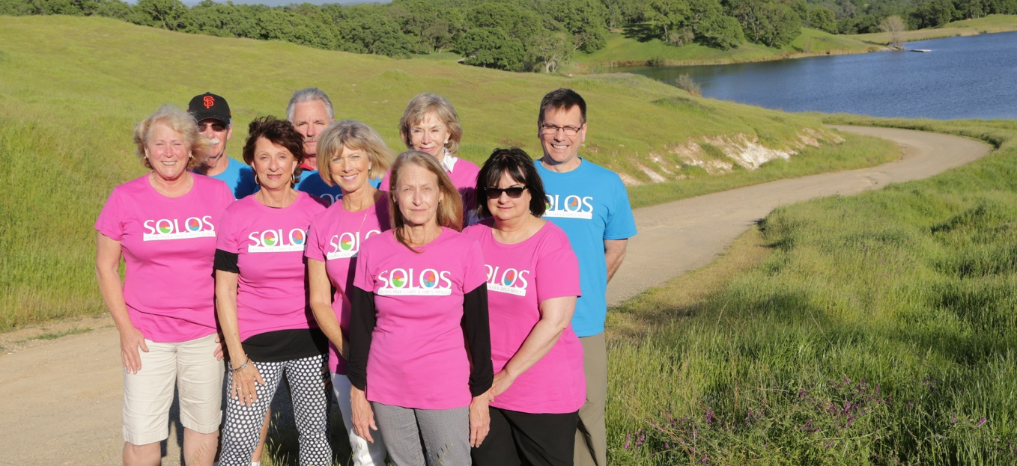
We are happy to report that our SOLOS Membership is now over 800 residents. The SOLOS Board shown below has worked hard to spread the word and recruit many new members over the past months. This has not only confirmed how much people care about Rancho Murieta and our beautiful wilderness environment, but it also confirms that people support our focus of working towards finding a way to “preserve” the trails and open spaces around our back lakes. SOLOS members are asked to help us continue to build our membership to meet our goal of 1000 by September 2017. Please ask you neighbors and RM friends to send their contact info to solosrm@aol.com It is that easy!
Thank you for your support and interest.
Cheryl McElhany, President (solosrm@aol.com)

